EIGHT QUEENS USING BACKTRACKING

PROGRAM:
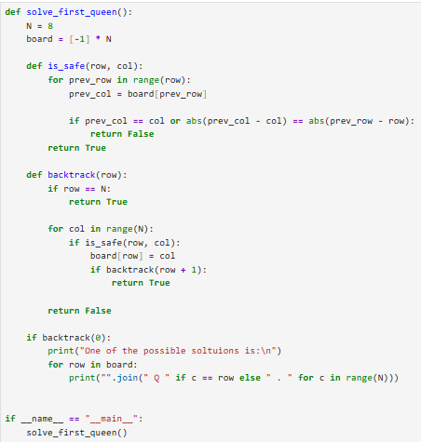
OUTPUT:
